# NetSuite Sales Process Assignment

**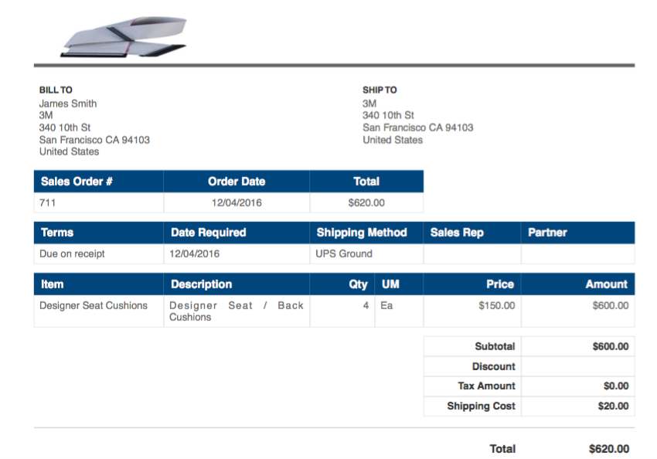Show or upload pdfs of sales order, invoice and payment receipt.**

**Sales Order**

**Assignment/3-invoice.pdf**

**Invoice**

**Assignment/4-payment.pdf**

**Payment**

# Goals: Go through the purchase process (from purchase to pay cycle)

**Show or upload pdf of purchase order and evidence of payment to vendor.**

**Assignment/PurchOrd_7230.pdf**

**Purchase Order**

Assignment/purchord7233.pdf

Payment Voucher

Assignment/Check7233.pdf

Payment Check